|  |  |  |  |  |
| --- | --- | --- | --- | --- |
| **C:\Users\Admin\AppData\Local\Microsoft\Windows\INetCache\Content.Word\VIT new logo.png**  **School of Electronics Engineering (SENSE)** | | | | |
| **PROJECT BASED LEARNING (CAMP) - REPORT** | | | | |
| **COURSE CODE / NAME** | BCSE308L – Computer Networks | | | |
| **PROGRAM / YEAR** | B.Tech (Electronics and Computer Engineering) | | | |
| **LAST DATE FOR REPORT SUBMISSION** | 20/11/24 | | | |
| **DATE OF SUBMISSION** | 14/11/24 | | | |
| **TEAM MEMBERS**  **DETAILS** | **REGISTER NO.** | **NAME** | | |
| 22BLC1184 | KESHIKA SWETHA.D | | |
| 22BLC1382 | AURUM JOSHI | | |
| **TITLE** | **Campus Network Design & Implementation** | | | |
| **COURSE HANDLER’S NAME** | **Dr. T. Jayavignesh** | | **REMARKS** |  |
| **COURSE HANDLER’S SIGN** |  | |

**Table of Content**

1.Abstract 3

2. Introduction 4

2.1 Network Design Principles 4

2.2 VLANs and Subnetting 4

2.3 Routing Protocols 4

2.4 DHCP and Dynamic IP Addressing 5

2.5 Simulation Tools 5

3. Algorithm 6

4. Implementation 7

4.1 Design 7

4.2 Planning 8

4.3 Testing 8

5. Coding 9

6. Results and Inferences 12

7. Application oriented learning 18

8. Conclusion 19

9. References 21

**ABSTRACT**

This project presents the design and implementation of a comprehensive campus network, utilizing Cisco Packet Tracer as a simulation tool. The objective was to create a robust and scalable network architecture that facilitates efficient communication across various departments within a campus environment. The project encompasses multiple key components, including the configuration of routers, switches, and a Dynamic Host Configuration Protocol (DHCP) server, alongside the establishment of Virtual Local Area Networks (VLANs) to segment traffic and enhance security. Through a systematic approach, the network was designed to support both wired and wireless connectivity, ensuring seamless access for users across different locations. The implementation phase involved configuring routing protocols, specifically RIP version 2, to optimize inter-VLAN communication and maintain network efficiency. Additionally, the project emphasized the importance of subnetting and IP addressing in creating a well-structured network layout. The successful completion of this project demonstrates the practical application of networking concepts and the effectiveness of simulation tools in network design. The resulting network not only meets the current demands of the campus but also provides a scalable solution for future expansion.

**INTRODUCTION**

In the contemporary digital landscape, the demand for efficient and reliable network infrastructure has become paramount, particularly in educational institutions where diverse user needs and applications coexist. A campus network serves as the backbone of communication and data exchange within an organization, facilitating connectivity among various departments, services, and users.

1. Network Design Principles:

Network design involves a systematic approach to creating an effective and scalable architecture. Key principles include modularity, scalability, reliability, and security. A modular design allows for easy upgrades and modifications, while scalability ensures that the network can accommodate future growth. Reliability is crucial for maintaining continuous service, and security measures protect sensitive data and resources.

2. VLANs and Subnetting:

Virtual Local Area Networks (VLANs) are essential for segmenting network traffic, improving performance, and enhancing security. By grouping devices into VLANs based on functional or departmental criteria, organizations can reduce broadcast domains, thus minimizing network congestion. Subnetting further optimizes IP address allocation and enhances routing efficiency by dividing larger networks into smaller, manageable segments.

3. Routing Protocols:

Routing protocols, such as Routing Information Protocol (RIP) version 2, play a critical role in facilitating communication between different network segments. RIP is a distance-vector protocol that uses hop count as a routing metric, enabling routers to share information about network topology and dynamically adjust routing tables. This adaptability is vital for maintaining optimal data flow and connectivity in a changing network environment. RIPv1 is the original protocol, and RIPv2 is the same but supports classless addresses and includes some security.

4. DHCP and Dynamic IP Addressing:

The Dynamic Host Configuration Protocol (DHCP) automates the process of IP address assignment, significantly simplifying network management. By dynamically allocating IP addresses to devices as they connect to the network, DHCP reduces the risk of address conflicts and streamlines the configuration process. This automation is particularly beneficial in environments with a high number of transient devices, such as educational institutions.

5. Simulation Tools:

Simulation tools like Cisco Packet Tracer provide a virtual environment for designing and testing network configurations without the need for physical hardware. These tools allow network designers to visualize complex topologies, troubleshoot issues, and experiment with different configurations, thereby enhancing the learning experience and facilitating practical application of networking concepts.

**ALGORITHM**

1. Define network requirements:

a. Identify departments and user needs

b. Determine number of devices and expected growth

2. Design network topology:

a. Choose hierarchical model (core, distribution, access)

b. Create physical layout diagram

3. Configure VLANs:

a. Assign VLAN IDs based on departments

b. Define IP subnets for each VLAN

4. Set up DHCP:

a. Install and configure DHCP server

b. Create scopes for each VLAN with IP range and options

5. Implement routing:

a. Configure routing protocol (e.g., RIP version 2)

b. Set up inter-VLAN routing on router

6. Test network connectivity:

a. Use ping and traceroute to verify device communication

b. Check DHCP address assignment and routing

7. Configure servers

a. Set up the email server and user setup in all devices

b. Set up web and ftp server

8. Troubleshoot any issues:

a. Identify and resolve configuration errors

b. Optimize settings for performance

9. Document network configuration and topology

**IMPLEMENTATION**

A comprehensive campus network for a university was designed and implemented using Cisco Packet Tracer. This network supports various departments, enabling efficient communication and resource sharing. The architecture includes multiple VLANs, a DHCP server for dynamic IP allocation, and inter-VLAN routing for seamless connectivity across different segments of the network.

**1.Design-**

Four faculties: Health and Science, Business, Engineering and Computing, Arts and Design

Main Campus:

* Three buildings: A, B, C
* Departments: Admin, HR, Finance, Business, Engineering and Computing, Arts , Student Labs and IT Department (hosts web server and email server)

Branch Campus:

* Faculty of Health and Sciences — Staff and student labs on separate floors

**2.Planning-**

Network Topology:

* Each department on a separate network
* Hierarchical model: Core, Distribution, Access layers
* Layer 3 switches for distribution as it allows configuration of multiple VLANs within a single switch, allowing it to serve as a bridge between them
* Access layer switches for departments

Configuration Details:

* Static routing for external server
* Dynamic IP addresses from DHCP server
* Use RIPv2 for internal routing
* Separate pools for each department

**3.Testing-**

Test connectivity between departments

Validate DHCP and routing configurations

Ensure successful communication across networks

**CODING**

**1.Basic Router Configuration**

* Enter global configuration mode - This moves the user into global configuration mode, where changes can be made to the router's running configuration.

Router> enable

Router# configure terminal

* Configure interfaces - By default, interfaces are shut down.

Router(config)# interface GigabitEthernet0/0

Router(config-if)# no shutdown

Router(config-if)# do wr

Router(config)# interface GigabitEthernet0/1

Router(config-if)# no shutdown

Router(config-if)# do wr

Router(config-if)# exit

* Set clock rate- Sets the clock rate for the serial interface, required when a router is acting as a DCE(Data Communications Equipment). It provides the clock signal to connected devices.

Router(config)# interface serial 0/0/0

Router(config-if)# clock rate 64000

* Assign ip address to router interfaces

Router(config)# interface GigabitEthernet0/0

Router(config-if)# ip address 192.168.1.1 255.255.255.0

2. VLAN Configuration (on Switches)

* VLANs (Virtual Local Area Networks) are used to logically segment networks within the same physical infrastructure, improving security and reducing broadcast domains.

Switch> enable

Switch# configure terminal

Switch(config)# int range fa0/1-24 *(Selects the specified range of FastEthernet interfaces for bulk configuration)*

Switch(config-if)# switchport mode access *(Configures the interfaces as access ports, allowing them to belong to a single VLAN)*

Switch(config-if)# switchport access vlan 10

Switch(config-if)# do wr

Switch(config-if)# exit

3. Trunk encapsulation

* Trunking is used to carry traffic for multiple VLANs over a single link, maintaining VLAN separation while optimizing network cabling.
* In distribution layer switches

Switch(config)# interface gigabitEthernet 0/0

Switch(config-if)# switchport trunk encapsulation dot1q *(Specifies the trunk encapsulation type as IEEE 802.1Q, a widely used VLAN tagging protocol)*

Switch(config-if)# switchport mode trunk *(Configures the port to allow traffic for multiple VLANs)*

* In routers

Router(config)# interface gigabitEthernet 0/1.10 *(Creates a subinterface for VLAN 10 on the physical interface)*

Router(config-subif)# encapsulation dot1Q 10 *(Configures the subinterface to use 802.1Q encapsulation with VLAN 10)*

Router(config-subif)# ip address 192.168.10.1 255.255.255.0 *(Assigns an IP address to the subinterface, allowing routing between VLANs)*

4. DHCP Server Configuration

* A DHCP server automates the assignment of IP addresses, subnet masks, gateways, and other network parameters to clients in a network, simplifying administration.

Router(config)# ip dhcp pool Department_A *(Creates a DHCP pool named "Department_A.")*

Router(dhcp-config)# network 192.168.1.0 255.255.255.0 *(Specifies the network range for which the DHCP server will lease addresses)*

Router(dhcp-config)# default-router 192.168.1.1 *(Sets the default gateway for DHCP clients)*

Router(dhcp-config)# dns-server [DNS_IP] *(Specifies the DNS server that DHCP clients should use)*

Router(dhcp-config)# exit

5. Routing Configuration (RIPv2)

* RIPv2 is a distance-vector routing protocol that shares routing table information within a network.

Router(config)# router rip

Router(config-router)# version 2 *(Configures the router to use RIPv2)*

Router(config-router)# network 192.168.1.0 *(Specifies the directly connected network to advertise in RIP updates)*

Router(config-router)# network 192.168.2.0 *(Specifies an additional network for advertisement)*

Router(config-router)# exit

**RESULTS & INFERENCES**

The project successfully configured VLANs for various departments, enabling enhanced traffic management and improved security within the network. The implementation of inter-VLAN routing facilitated seamless communication between different VLANs, promoting efficient data exchange across the campus. Additionally, the DHCP server was set up effectively, providing dynamic IP addresses to network devices, which greatly simplified device management and reduced administrative workload. The integration of email, FTP, and web servers within the campus network further enhanced communication, collaboration, and resource sharing among users.

The design is scalable, allowing for future expansion, such as the addition of new departments or buildings, without the need for significant reconfiguration. Implementing VLANs is essential for bolstering network security and minimizing broadcast traffic in large networks, particularly in educational settings where access requirements differ between departments. The use of a DHCP server proved crucial for efficient IP management, easing the task of assigning IP addresses manually and ensuring optimal network operations.

Enabling inter-VLAN routing was a key component for fostering collaboration between departments, underscoring the importance of robust routing protocols in a comprehensive campus network. This project also highlights the significance of thoughtful network design, which includes planning for redundancy, load balancing, and fault tolerance to maintain high availability and reliability. The design principles demonstrated in this project can serve as a benchmark for future enterprise network designs, showcasing adaptable best practices to meet evolving technological needs.

IP ROUTE-

PING-

TRACERT-

WEB SERVER-

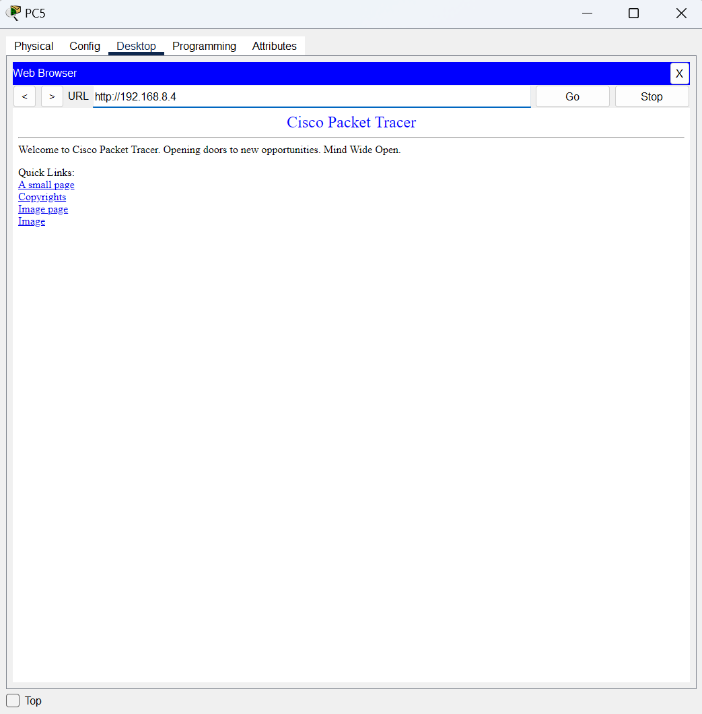

EMAIL SERVER-

FTP SERVER-

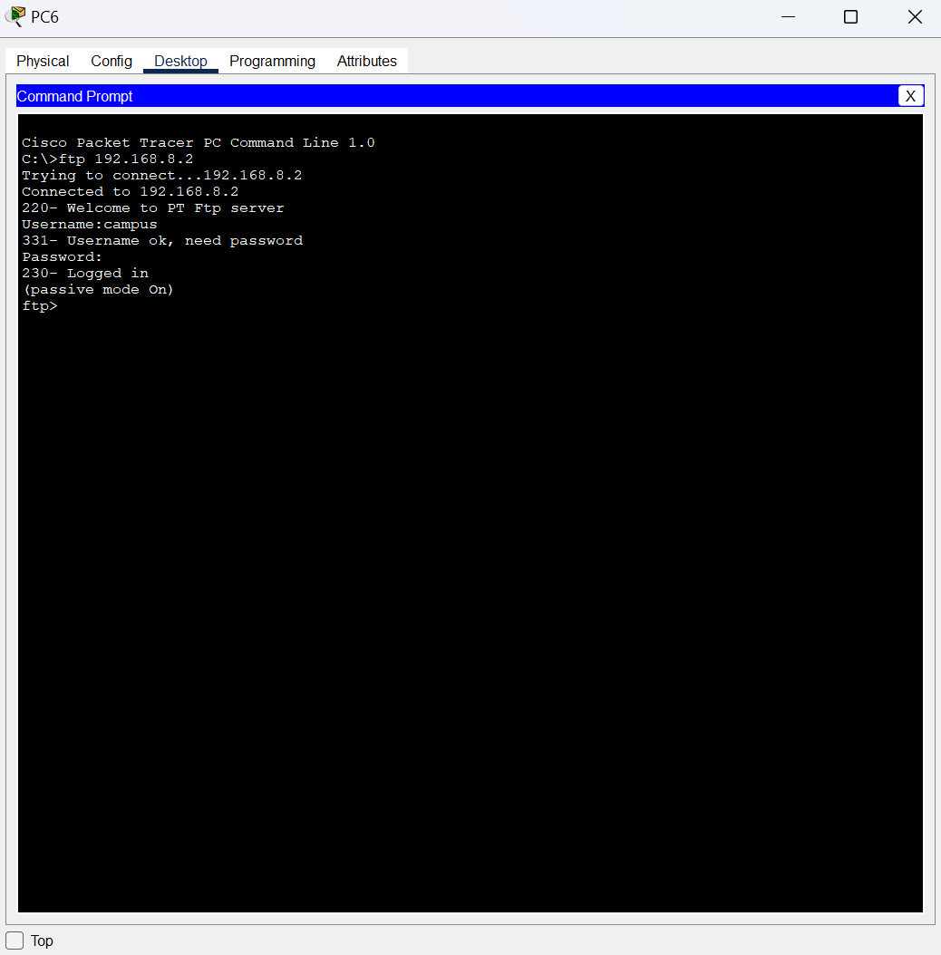

**APPLICATION ORIENTED LEARNING**

The campus network design and implementation project can be leveraged in real-world applications, showcasing fundamental concepts of computer communication. The network supports online learning systems, enabling students and faculty to access course materials, submit assignments, and participate in virtual classrooms seamlessly. Researchers can use FTP servers to share large datasets and collaborate on projects, ensuring quicker data transfer and efficient access to shared resources. The email server facilitates both internal and external communication, allowing faculty and students to exchange information swiftly and securely. Additionally, the web server can host departmental websites, providing comprehensive information on courses, faculty, and events, thereby enhancing the university's online presence.

The project provided an in-depth understanding of various key networking concepts and their practical implications. It explored different network topologies, such as star, bus, and ring, emphasizing their impact on performance and reliability. Implementing VLANs and subnetting was integral for network segmentation, enhancing security and performance, while demonstrating how subnetting optimizes IP address management. The project also covered routing and switching, including inter-VLAN routing and the application of routing protocols to manage data traffic efficiently. A thorough review of communication protocols such as TCP/IP, HTTP, FTP, and SMTP highlighted their roles in facilitating reliable data transfer and communication. Configuring servers—specifically email, FTP, and web servers—underscored their importance in supporting a networked environment. Understanding DHCP for dynamic IP addressing showcased its role in reducing administrative tasks and simplifying network management.

The skills and concepts learned from the campus network design project are directly applicable to real-world scenarios in educational institutions and other organizations. They provide a foundational understanding of how to design, implement, and manage complex network infrastructures to support various applications and services.

**CONCLUSION**

Designing and implementing the campus network came with notable challenges. Managing a complex layout that accommodated multiple departments and buildings required intricate planning, particularly when configuring VLANs and facilitating inter-VLAN routing. Ensuring that the network could scale effectively for future expansions, such as additional buildings or increased user demand, involved strategic foresight and design. Integrating essential services like email, FTP, and web servers posed compatibility issues and required careful coordination to maintain seamless operation across diverse platforms.

Looking ahead, the network can be enhanced by implementing advanced security protocols, improved firewalls, and regular security audits to safeguard against unauthorized access and potential breaches. Network automation tools, such as Ansible and Software-Defined Networking (SDN), could be employed to simplify configuration management, reduce manual intervention, and improve operational efficiency. The integration of Internet of Things (IoT) devices should be prioritized, ensuring secure and efficient incorporation into the network infrastructure. Cloud-based services could be leveraged for storage, applications, and backup solutions, enhancing both scalability and resilience. Comprehensive disaster recovery and business continuity plans would provide assurance of network reliability during unexpected outages or emergencies. Further, continued research into emerging networking technologies, such as 5G and Wi-Fi 6, could open new avenues for innovative enhancements that support the evolving needs of the campus community.

This project underscores the importance of strategic planning, robust design, and the use of best practices in network architecture. The lessons learned and future directions highlighted here set a foundation for ongoing improvement, fostering a network capable of adapting to the ever-changing technological landscape while meeting the needs of its users.

**REFERENCES**

* Cisco Networking Academy. (n.d.). *Cisco Networking Academy: Courses and Certifications*. Retrieved from <https://www.netacad.com/>
* Kurose, J., & Ross, K. (2021). *Computer Networking: A Top-Down Approach* (8th ed.). Pearson.
* RFC Editor. (n.d.). *RFC Database*. Retrieved from <https://www.rfc-editor.org/>
* Cisco Systems, Inc. (n.d.). *Cisco Configuration Guides and Command References*. Retrieved from https://www.cisco.com/c/en/us/support/docs.html
* West, J., Dean, T., & Andrews, J. (2021). *Network+ Guide to Networks* (8th ed.). Cengage Learning.
* Cisco Networking Academy. (2020). *Routing and Switching Essentials v7.0 Companion Guide*. Cisco Press.
* Juniper Networks. (n.d.). *Whitepapers on VLAN Management and DHCP Protocols*. Retrieved from <https://www.juniper.net/>
* National Institute of Standards and Technology (NIST). (n.d.). *NIST Special Publications on Cybersecurity*. Retrieved from <https://csrc.nist.gov/publications/sp>
* TechTarget. (n.d.). VLAN and DHCP Protocol Documentation. Retrieved from https://www.techtarget.com/

GITHUB LINK- https://github.com/JoshuaSmort/Computer-Networks